Patient Reference/Participation Group Annual Report 2013/14

This report summarises the progression of our Patient Reference/Participation Group (PRPG) and includes:

- A profile of the practice population
- The efforts to date to recruit new members to the PPG
- Priorities for the practice survey and how they were agreed
- Method and results of the patient survey
- Resulting Action plan and how it was agreed with our PPG
- Confirmation of our opening times

Practice Profile Summary

Age & Sex Profile

Dr Wright & Partners are one of two practices situated in Heald Green Health Centre in the Stockport area and has a list size of 6360 registered patients. Of these patients, 59% are female and 41% male. 62% of the population is aged between 16 – 65 years, 20% aged 65 years and over and 21% are under 16 years. A data field is included in our patient registration documentation and to date we have READ coded ethnicity status for 80% of the practice population. Some patients however have declined to provide this information and this makes it difficult to be sure the search data is entirely accurate & representative of our true patient population. Searches indicate that 70% of our patients are of White British origin and 30% are a mix of Asian/African & Eastern European. The Practice does not serve a particularly large number of nursing home patients or a significant number of patients with learning disabilities or from any other care group.

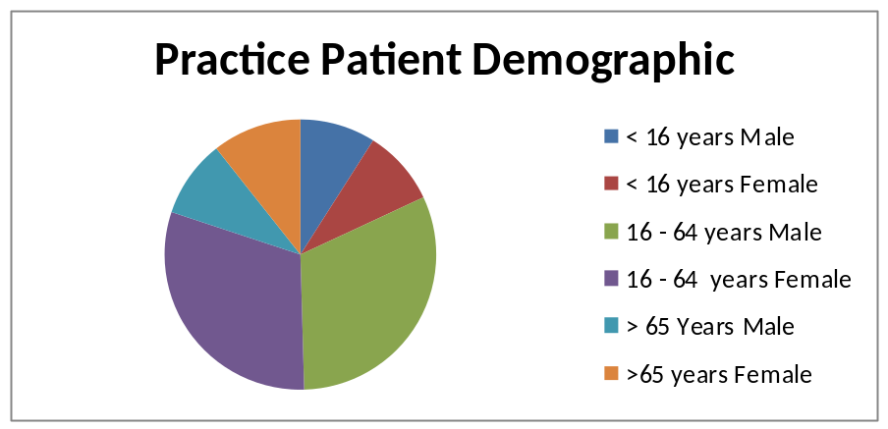

PRG Profile

The group originally started up almost 20 years ago and is now a very well established and active group within the local community. Since launching a campaign to promote the group by placing posters in the waiting room, dedicated notice board, practice leaflets and website we have this year increased the members of the group from 42 (31 March 2013 ) to 184 patients who are coded as belonging to the group and the committee is made up of 15-20 hard core members including a Chair Person and Secretary.

The group meets on the first Thursday in the month at the Health Centre where they discuss local issues and often have a variety of guest speakers ranging from clinicians to CCG and secondary care providers.

Although the overall group demographic has changed from being predominantly aged 65 and over to 42% of members now being aged 16 – 64 years, the core members who regularly attend the meetings and events and serve on the group’s committee continue to consist mainly of patients of more mature years and predominantly retired and are mainly of a white background. All patients are emailed (bcc) regular updates of the forthcoming events, practice newsletters, surveys etc as feedback has shown that some patients prefer to get involved with the group and the practice on a virtual basis.

Actions taken to recruit

In addition to the posters in the waiting room, dedicated notice board, practice leaflets and website all encouraging new members, the PPRG group has worked closely with the practice and assisted in the development and implementation of this year’s Practice survey which took place throughout the flu campaigns. This was seen as a prime opportunity to promote the group and gather up to date patient contact details.

In addition we have also used the following methods:

- Details of the group and how to get involved have also been incorporated into our New Patient Registration Packs.
- Receptionist continue to proactively collect and record patient email addresses so that blanket invites can be sent out to patients who would like to get involved but prefer to belong to the virtual aspect group .
- Doctors continue to invite patients personally during consultations and this is slowly starting to increase interest.
- The patient LED board is being used to full capacity to promote awareness of the group and the need for up to date patient contact details, website address and facilities on a rotational basis.
- Practice Surveys

Practice Survey

This year in order to reach as many patients as possible, including those who may not come into the surgery very often we decided to make the survey available to download or complete online via the Practice website in addition to the PPRG physically handing out questionnaires in practice during the flu clinics.

The practice’s Access & Availability survey was originally drafted the previous year with PPRG during the review of the findings from the National survey but was put on hold to September/October 2013. In order to ensure the PPRG were still happy with the contents a draft of the questionnaire was sent out by email to the group members in August 2013. A few minor amendments were made as a direct result of this and the questionnaire was launched in October 2013.


250 questionnaires were completed and the responses collated using the software available on the website. The results were then published on the practice website, notice board and also emailed out to group members.


Action Plan

A further meeting with the PPRG took place to review the survey results on 4th December and an action plan was developed as a result of this. The Action Plan was circulated along with a copy of the meeting minutes by email to all the group members and published on the website and notice board in the surgery and approval was received the committee chairman on behalf of the members.

A review of the Action Plan to establish achievement to date was undertaken at the PPRG committee meeting on 25/02/14 and details of these were added as a footnote to the original plans. These were then distributed to the group members.


Opening Hours

Reception is open 8.00am – 6.30pm Monday – Friday
Appointments are available 8.00am – 6.00pm Monday – Friday

Mastercall provides emergency cover for the Practice outside of these hours.

In addition to the core hours, the practice also offers extended hours. These are held on Tuesday evenings (6.30pm – 8.00pm)on a rota basis and patients are advised to contact the reception desk for further details.

This report has been published on the Practice website and is available in hard copy for any patients who would like one.

